TPMS Module Information
Source ID | CAN Node ID
$23 | $24F

DVT Test Procedure

2、Reset Frame Counter
1、Clear DTCs
Vehicle Into
DVT

Test Procedure Requirement
3、Vehicle Testing

4、Read Factory Mode
5、Read Frame Counter
6、Check Code

7、Test Complete

1、Clear DTCs
Type | Number | Message  Node/Len/Data | Feedback | Comment
Clear DTCs |  | 24F /08 /  01 04 00 00 00 00 |  | DVT Department send
Answer |  |  | 64F /08 /  01 44 00 00 00 00 00 00 | TPM send

2、Reset Tire Pressure Module Frame Counter
Type | Number | Message  Node/Len/Data | Feedback | Comment
Reset Frame Counter | CPID $13 | 24F /08 /  06 AE 13 04 00 04 00 00 |  | DVT Department send
Answer |  |  | 64F /08 /  02 EE 13 E3 04 06 00 00 | TPM send
*The PID CA4E/CA4F will be Clear Zero when module received this message
3、Vehicle Testing
Requirement： The duration of the vehicle speed is over than 30km/h for more than 30 seconds.
4、Read Tire Pressure Sensor Factory Mode Information
Type | Number | Message  Node/Len/Data | Feedback | Comment
Read LF Factory Info | PID CB03 | 24F /08 /  03 22 CB 03 00 00 00 00 |  | DVT Department send
Answer |  |  | 64F /08 /  04 62 CB 03 ZZ | TPM send
Read RF Factory Info | PID CB04 | 24F /08 /  03 22 CB 04 00 00 00 00 |  | DVT Department send
Answer |  |  | 64F /08 /  04 62 CB 04 ZZ | TPM send
Read RR Factory Info | PID CB05 | 24F /08 /  03 22 CB 05 00 00 00 00 |  | DVT Department send
Answer |  |  | 64F /08 /  04 62 CB 05 ZZ | TPM send
Read RL Factory Info | PID CB06 | 24F /08 /  03 22 CB 06 00 00 00 00 |  | DVT Department send
Answer |  |  | 64F /08 /  04 62 CB 06 ZZ | TPM send

5、Read Tire Pressure Module Frame Counter
Type | Number | Message  Node/Len/Data | Feedback | Comment
Read Front  Frame Counter | PID CA4E | 24F /08 /  03 22 CA 4E 00 00 00 00 |  | DVT Department send
Answer |  |  | 64F /08 /  07 62 CA 4E ZZ | TPM send
Read Rear  Frame Counter | PID CA4F | 24F /08 /  03 22 CA 4F 00 00 00 00 |  | DVT Department send
Answer |  |  | 64F /08 /  07 62 CA 4F ZZ | TPM send

6、Check Code
Type | Number | Message  Node/Len/Data | Feedback | Comment
Check Code |  | 24F /08 /  03 A9 81 52 00 00 00 00 |  | DVT Department send
Answer |  |  | 64F /08 /  81 00 00 00 52 00 00 00 | TPM send

Part Test Pass Criteria

Reference
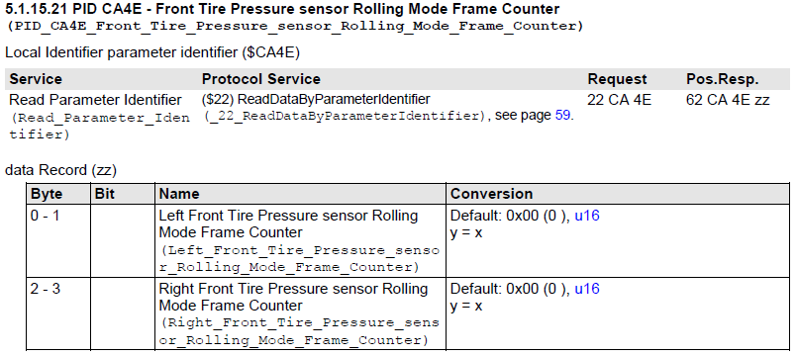
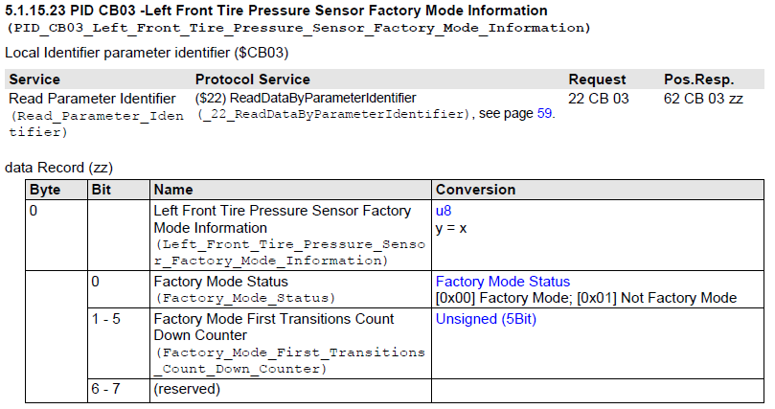

Factory Mode | Frame Counter | DTCs | Result | Comment
XX XX XX X0(Bin) | Each PID value > 0  PID CA4E&CA4F > 0 | N/A | Succeed
XX XX XX X0(Bin) | One of PID value = 0  PID CA4E&CA4F = 0 | N/A | Fail | Error Text  [Conner]Sensor Can’t receive data
XX XX XX X1(Bin) | No case | N/A | TBD | [Conner]Sensor not in Factory mode
No case | No case | Error code | Fail | Display corresponding Code

DTC Parse Table for Check Code

Code | DTC | Type | Error text | Chinese
0x4569 | C0569 | 0x00 | System Configuration Error | 系统配置故障
0x4750 | C0750 | 0x03 | Left Front Low Tire Pressure Sensor Voltage below threshold | 左前轮传感器电池电量低
0x4750 | C0750 | 0x29 | Left Front Low Tire Pressure Sensor too few pulses | 左前轮传感器信号故障
0x4750 | C0750 | 0x39 | Left Front Low Tire Pressure Sensor internal electronic failure | 左前轮传感器故障
0x4755 | C0755 | 0x03 | Right Front Low Tire Pressure Sensor voltage below threshold | 右前轮传感器电池电量低
0x4755 | C0755 | 0x29 | Right Front Low Tire Pressure Sensor too few pulses | 右前轮传感器信号故障
0x4755 | C0755 | 0x39 | Right Front Low Tire Pressure Sensor internal electronic failure | 右前轮传感器故障
0x4760 | C0760 | 0x03 | Left Rear Low Tire Pressure Sensor voltage below threshold | 右后轮传感器电池电量低
0x4760 | C0760 | 0x29 | Left Rear Low Tire Pressure Sensor too few pulses | 右后轮传感器信号故障
0x4760 | C0760 | 0x39 | Left Rear Low Tire Pressure Sensor internal electronic failure | 右后轮传感器故障
0x4765 | C0765 | 0x29 | Right Rear Low Tire Pressure Sensor too few pulses | 左后轮传感器电池电量低
0x4765 | C0765 | 0x39 | Right Rear Low Tire Pressure Sensor internal electronic failure | 左后轮传感器信号故障
0x4775 | C0775 | 0x00 | Low Tire Pressure System Sensors Not Learned no additional information | 左后轮传感器故障
0x9517 | B1517 | 0x03 | Battery Voltage Below Threshold | 模块供电电压低于9V
0x9517 | B1517 | 0x07 | Battery Voltage Above Threshold | 模块供电电压高于16V
0xC100 | U0100 | 0x00 | Lost Communication with ECM | ECM模块连接中断
0xC140 | U0140 | 0x00 | Lost communication with BCM | BCM模块连接中断

